Document: FCILekha Pension Manual | Version:12.0



Error: Reference source not found

User Guide: Pension Manual



AUGUST 2016

Confidentiality

© 2007 TECH MAHINDRA

This document contains information that is proprietary and confidential to Tata Consultancy Services, which shall not be disclosed outside Food Corporation of India, transmitted, or duplicated, used in whole or in part for any purpose other than its intended purpose. Any use or disclosure in whole or in part of this information without express written permission of Tata Consultancy Services is prohibited. Any other company and product names mentioned are used for identification purposes only, and may be trademarks of their respective owners.

Document Control

Revision Details

Date | Author | Version | Change Reference
10-MAR-2017 | TCS | 12.0 | FAP R12 Upgrade

Distribution

Copy No. | Name | Location | Role | Position | Date
1 | FCI Management | Delhi HQ |  |  | 10-03-2017
2

DOCUMENT RELEASE NOTICE
Notice No.:
Client: Food Corporation of India
Project: Oracle Application 12 Upgrade
Document Details:

Name | Version No. | Description
FCILekha Pension Manual | 12.0 | Initial Version

Revision Details:

Action taken  (Add / delete / change) | Preceding  Page No. | New  Page No. | Revision  Description

Change Register serial numbers covered:
The documents or revised pages are subject to document control.
Please keep them up-to-date using the release notices from the distributor of the document.
These are confidential documents. Unauthorized access or copying is prohibited.

Approved by: Date:

Authorized by: Date:

TABLE OF CONTENTS

TABLE OF CONTENTS 5
Introduction 6
About this Guide 6
Getting Started and Logon Process 7
1. Pension Employer Share Upload 10
2. Reports 13
2.1. FCI Pension Details Report (Unit Wise) 13
2.2. Unit Wise Consolidated Report (Unit Wise) ………………………………….18
2.3. Pension Slip Report (Employee Wise)……………………………………………21
3. Pension Final Settlement Screen(HQ)……………………………………..… 22

Introduction
The purpose of this training document is to give the intended users step by step operating instructions in doing the Employee Pension related activities in TCS Payroll Management System.
A fixed component is deducted every month from the salary of the employees as Employee Pension contribution. Present rate of employee contribution to the Pension Fund is 2% of (Basic + DA+ Stagnation Increment) and the Employer contributes in 10% of (Basic + DA+ Stagnation Increment) in the pension fund for that Employee. In case an employee wants to contribute more to the Pension Fund then he can do so.

About this Guide
This user’s guide provides complete and detailed information on performing the Payroll-Pension functions in Payroll Management System.

This guide includes:
- Procedures for the tasks you need to perform
- Reference information on fields, messages and reports.

Getting Started and Logon Process

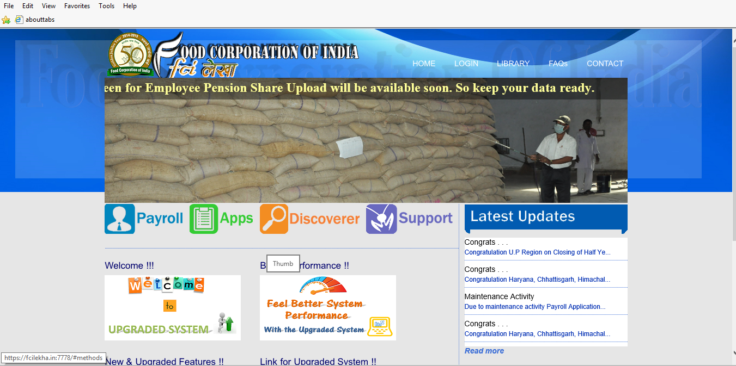

Click on “Payroll” button to login to Payroll System. The system will ask for valid user id and password.

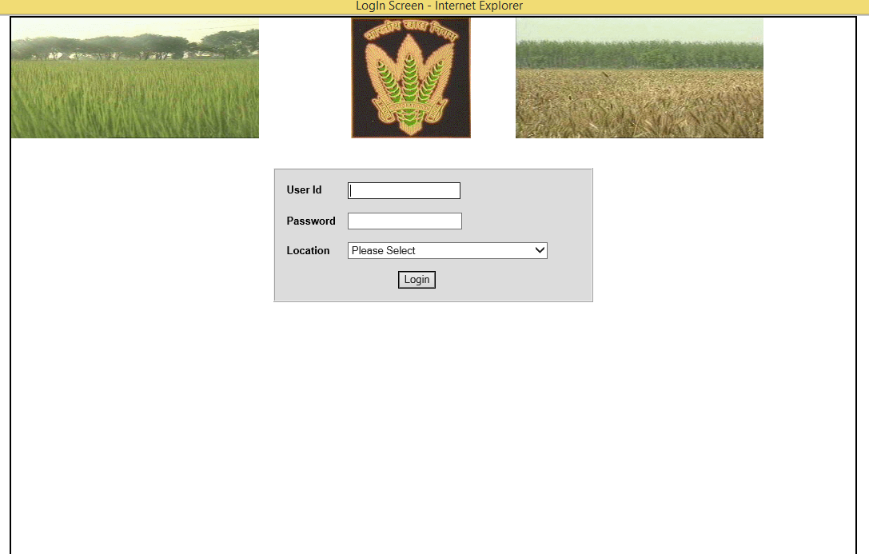

Use your own login credentials to login the system. Select a login location from the dropdown to login specific to that location

Note: This URL may change thereafter, so please contact your system administrator for the correct URL.

Click on the Login button. The Main Page screen appears as shown below.

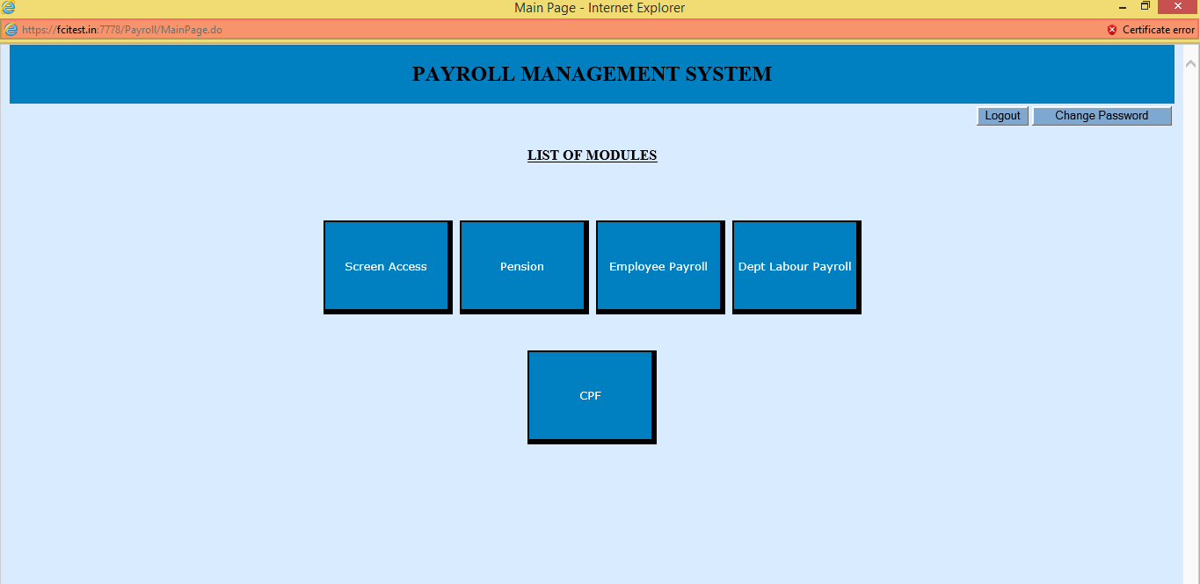

Click on the Pension button. The Pension screen appears as shown below

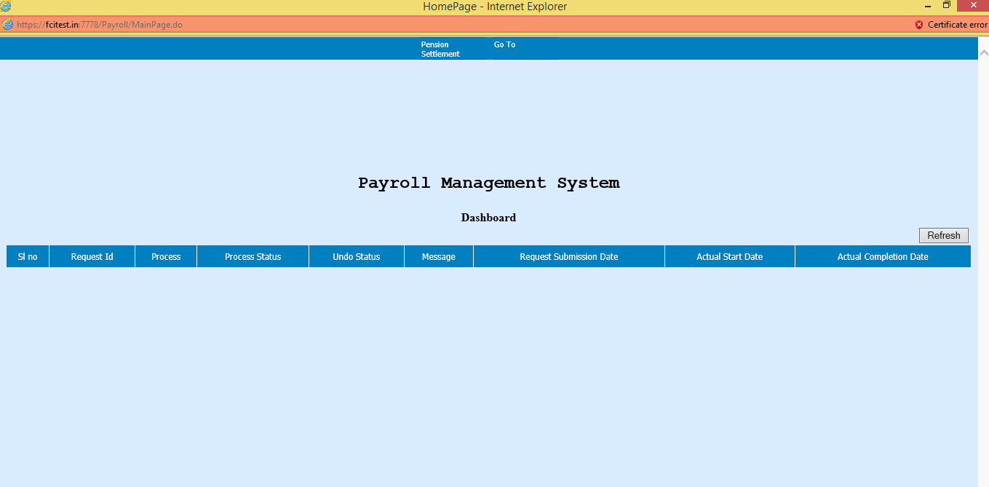

Pension Employer Share Upload

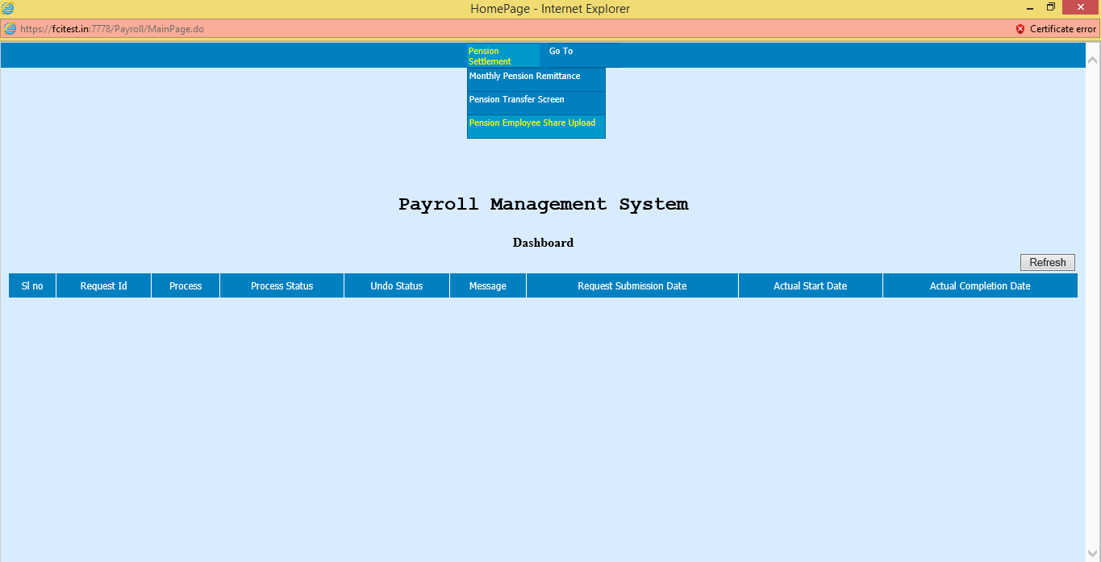

Task Name: Pension Employer Share Upload

Task Description:

The screen allows the user to enter the Employer pension contribution Details in the System.

Prerequisites for performing the task:

The site should be in the UNDO Stage at the time of entering details on the screen.

Users who can perform the task:

Users from HR/EDP/Finance/Pension departments.

Task Procedure
- In the main menu select Pension Settlement→ Employee Pension Share Upload
- The Employee Pension Share Upload screen appears in new mode.
- To view all the existing Pension Share Upload, click on the Get Detail button.
- To Add a Row, click on the Add row button. A blank row is added at the end.
- To enter the details specific to an Employee, select the Employee Number from the list of values and Enter the Details for that particular employee.

- To delete a Row, select the row and click on the Delete Row button. Note that after saving the existing record can’t be deleted. Only you can delete the records before saving the records.
- To save, click on the Save icon. After saving, the message “Data Saved Successfully” is displayed.
- After saving the Data the Net Employer OB amount will automatically generated.
- GO button can be used to switch between different pages.
- To close the screen click on the Exit button.

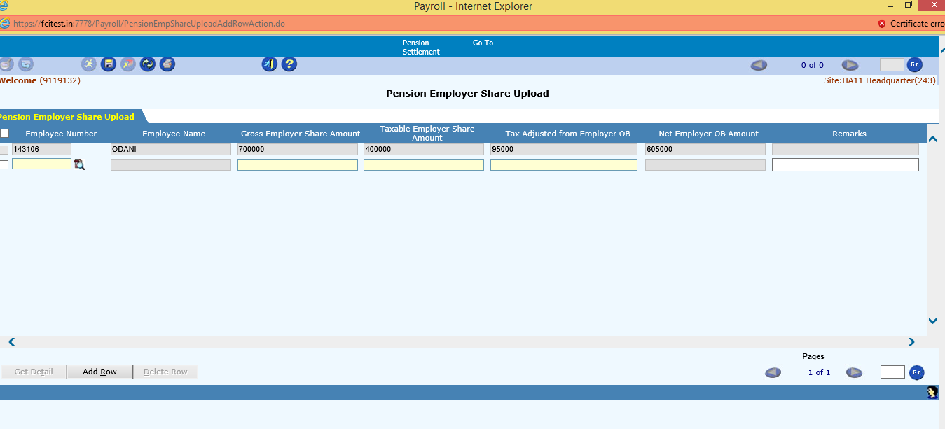

Field Description (Pension Employer Share Upload)

Field Name | Field Type | Data Type | Description
Employee Number | Mandatory | Numeric | Select an employee from the list of values.
Employee Name | Mandatory | Character | This field will be auto populated after selecting the employee number.
Gross Employer Share Amount | Mandatory | Numeric | Enter the Gross Employer Share Amount. The amount entered should be between 0 and 10 lakhs. This is the Total amount of First installment of Employer Pension Share Arrear as calculated by the user. The System shall consider the amount entered by the user only.
Taxable Employer Share Amount | Mandatory | Numeric | Enter the taxable Employer Share Amount. This amount can’t be greater than gross employer share amount. This is the taxable Employer Pension Arrear Share amount out of the gross employer share arrear amount as calculated by the user. The System shall consider the amount entered by the user only. This amount will be automatically considered in the total taxable income of the employee and will be considerable under the I.T Forecast in the respective FY w.r.f the date of entry.
Tax Adjusted from Employer OB | Mandatory | Numeric | Enter the tax Adjusted from Employer OB. This amount can’t be greater than Taxable Employer Share Amount. This is the net tax payable on taxable employer arrear share as calculated by the user. The System shall consider the amount entered by the user only. The amount which has been fed in the above screen, user has to enter an invoice in AP in favor of tax authority to remit the tax
Net Employer OB Amount | Mandatory | Numeric | The Net Employer OB Amount will be auto populated after entering the above fields. The formula used to calculate this amount is given as : Gross Employer Share Amount- Tax Adjusted from Employer OB
Remarks | Optional | Character | User can enter any Remarks.

Sample Entry:

Employee Number | Gross Employer Share Amount | Taxable Employer Share Amount | Tax Adjusted from Employer OB | Net Employer OB Amount
276xxxx | 500000 | 300000 | 90000 | 410000

In the example above, user has entered the Gross Employer share Amount as 500000 out of which 300000 is Taxable Employer share, (considering tax@ 30%, taken just for the sake of example: exact tax% to be decided manually by the user ) - user has entered 90000 as the Tax to be adjusted from Employer OB.

So, the Net Employer OB amount is auto calculated by the system as 500000- 90000= 410000

Reports

FCI Pension Details Report (Unit Wise)

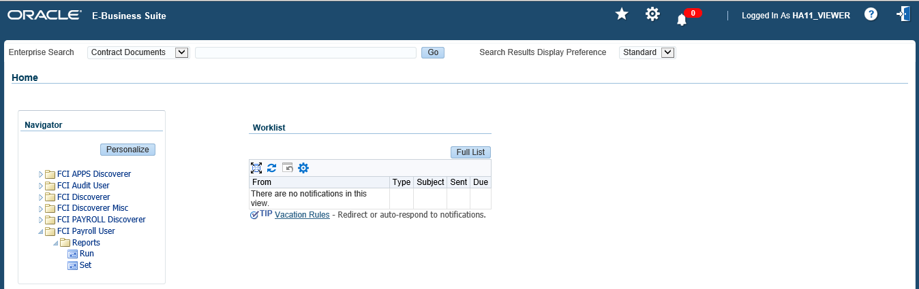

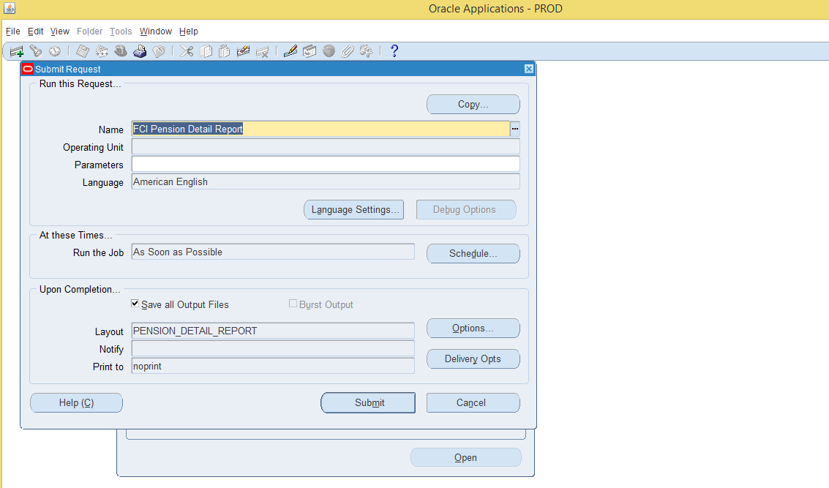

Task Name: FCI Pension Details Report

Task Description:

This Report gives the pension details of the Employees posted at the current location for the specified Year Month. This will be a monthly report.
Prerequisites for performing the task:

Month End Process should be completed for the YEARMONTH

Users who can perform the task:

All Users on Site Level.
Task Procedure
- The user need to login via APPS Screen using his/her credentials.
- Go to FCI Payroll User -> Reports->Run.
- Select FCI Pension Details Report.
- Enter the Year Month and Location for which the report is needed.
- To generate the report, click on the Submit button.
- To See the output of the reports go to View->Requests
- Download the Output of the Report.

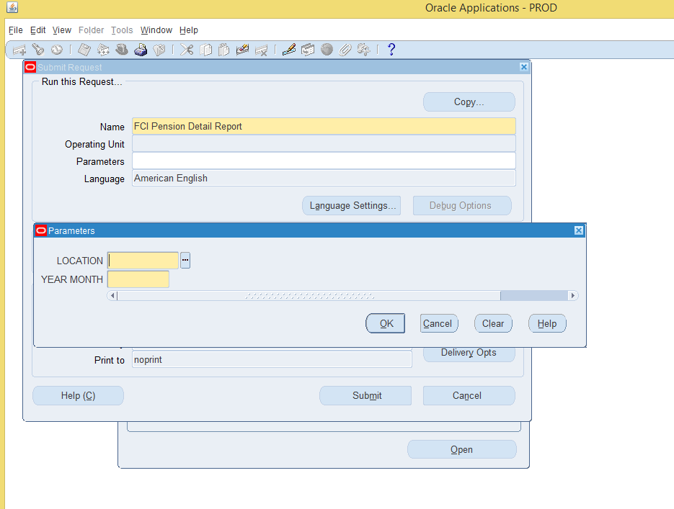

Field Description (Report Parameters)

Field Name | Field Type | Data Type | Description
Location | Mandatory | Numeric | Select the Site ID from the list of values, for which the report is needed.
Year month | Mandatory | Numeric | Select the Year Month from the list of values, for which the report is needed.

Report Layout:

PENSION DETAILS REPORT

Emp Num | Emp Name | Date Of Birth | Date Of Joining | Gender | Pension Number | Lic  Policy | Supplimentary Basic | Supplimentary Da | Monthly Basic | Monthly Da

Supplimentary Employee Cont | Supplimentary Employer Cont. | Monthly Employer Cont | Monthly Employee Cont | Voluntary Employee Cont | Pension Admin Fee | Employee Arrear Cont

Supplimentary Total(Monthly+DA) | Monthly Total(Monthly+DA)

Report Layout:

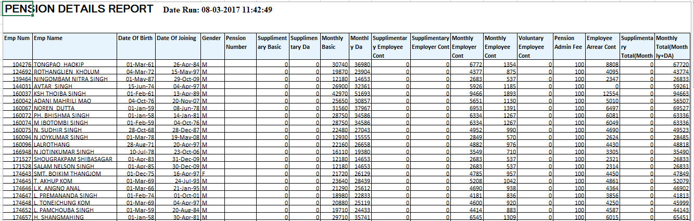

  - FCI Unit Wise Consolidated Pension Report (Unit Wise)

Task Name: FCI Unit Wise Consolidated Pension Report

Task Description:

This Report gives the pension details of the Unit for the specified Year Month according to the LIC Policy. This will be a monthly report.
Prerequisites for performing the task:

Month End Process should be completed for the YEARMONTH

Users who can perform the task:

Unit level.
Task Procedure
- The user need to login via APPS Screen using his/her credentials.
- Go to FCI Payroll User -> Reports->Run.
- Select FCI Unit Wise Pension Detail Report.
- Enter the Year Month ,LIC Policy and Location for which the report is needed.
- To generate the report, click on the Submit button.
- To See the output of the reports go to View->Requests
- Download the Output of the Report.

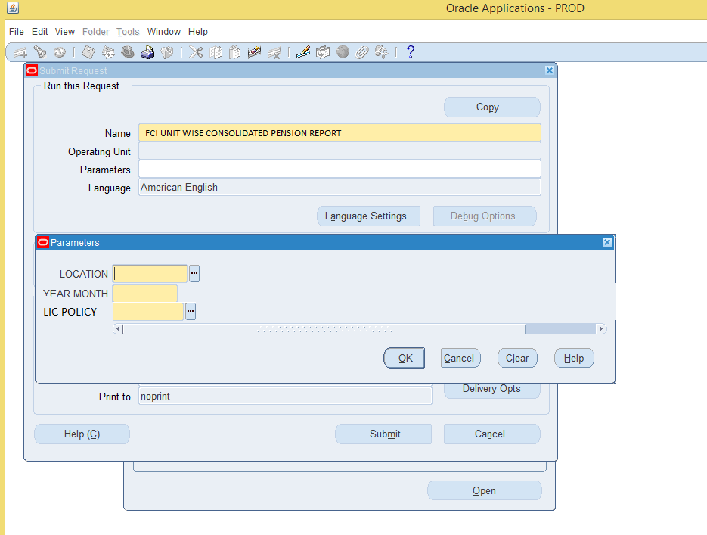

Field Description (Report Parameters)

Field Name | Field Type | Data Type | Description
Location | Mandatory | Numeric | Select the Site ID from the list of values, for which the report is needed.
LIC Policy | Mandatory | Variable | Select the require\d Policy  1) New Policy → Employees whose joining date is after 31st March 2021 or DCPS contribution is deducting first time by payroll on or after 01st April 2021  2) Old Policy → Employees whose joining date is before 01st April 2021  3) Settled → For those cases for whom annuity case under Old Master Policy has already been settled/entered in Pension Final Settlement Screen
Year month | Mandatory | Numeric | Select the Year Month from the list of values, for which the report is needed.

Report Layout:

Created Site Id |  | Loc Desc |  | Year Month | Pension Admin Fee |  | Monthly Basic |  | Monthly Da |  | Monthly Total |  | Monthly Employee Cont
Monthly Employer Cont |  | Supplimentary Basic |  | Supplimentary Da | Supplimentary Total |  | Supplimentary Employee Cont |  | Supplimentary Employer Cont |  | Voluntary Employee Cont |  | Gross Basic
Gross Da | Gross Employee Cont |  | Gross Employer Cont |  |  | Employee Arrear Cont |  | Employer Arrear Cont |  | Grand Total

2.3 Pension Slip Report (Employee Wise)

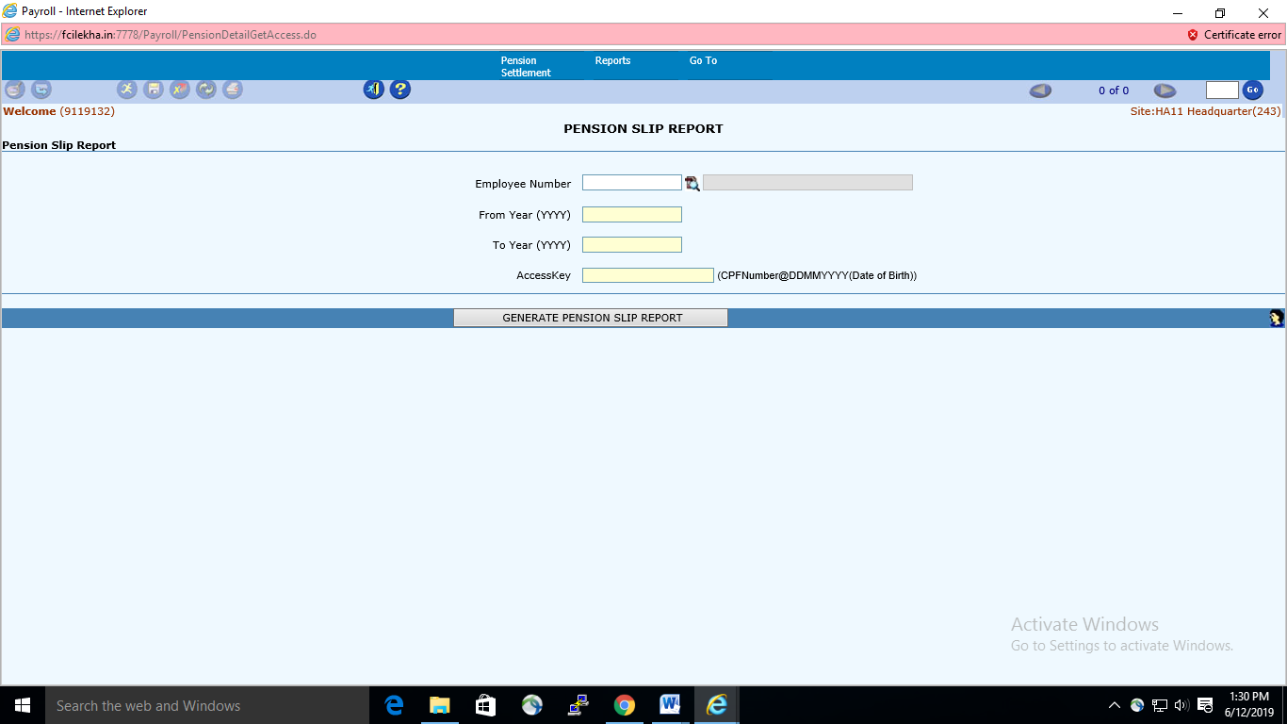

Task Name: Pension Slip Report

Task Description:

This Report gives the pension details of the individual Employee posted at the current location for the specified Year Month.
Prerequisites for performing the task:

Month End Process should be completed for the YEARMONTH

Users who can perform the task:

All Users on Site Level.
Task Procedure
- The user need to login via Payroll Screen using his/her credentials.
- Go to Pension module -> Reports->Pension Slip.
- Select FCI Pension Slip.
- Select Employee Number.
- Enter the From Year and to Year for which the report is needed.
- Enter Access Key (CPFNumber@DDMMYYYY(Date of Birth)) of the selected employee.
- To generate the report, click on the GENERATE PENSION SLIP REPORT button.
- Report Downloaded in .pdf format.

- PENSION FINAL SETTLEMENT SCREEN

As per CR , Pension Final Settlement is required by FCI so that annuity provider can be selected and the balances can be knocked off through the payroll, after the separation process for all employees of category I,II,III & IV.

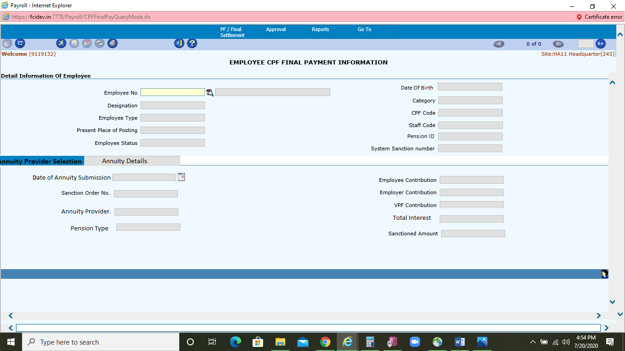

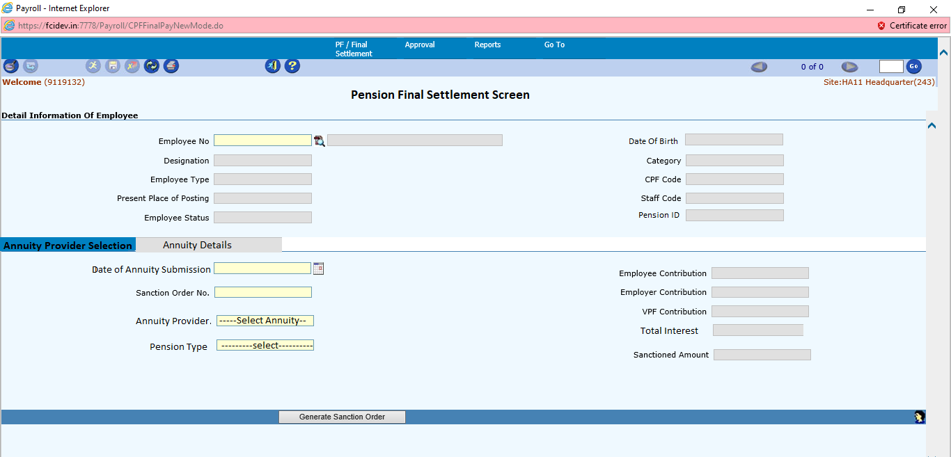

Task Name: Pension Final Settlement

Task Description:

This Screen is required in pension module to select the annuity provider and knocking off pension balances through the payroll after the separation process.
Prerequisites for performing the task:

Final Separation process must be completed before this process.

Users who can perform the task:

Screen is accessible only at Headquarter end.
Task Procedure
- The user need to login via Payroll Screen using his/her credentials.
- Go to Pension module -> PF/FINAL Settlement->Pension Final Settlement
- Select Employee Number.
- Enter the annuity details which are marked as mandatory.
- Then click on generate sanction tab. System will knock off the pension balances as per sanction date.
- After entering the annuity details ,rest of the details shall be entered by user or pension Division for the final process.

Once the sanction order is generated and user has made the annuity details, the pension Adjustment screen will not work for that particular employee.

There will be an option to cancel the sanction. On cancellation the pension balances for employer, employee and VPF shall be rolled back in the OBCB and pension slip report, however once annuity is generated the cancellation option for sanction order shall not work.

3.1 List of Sanction Report

“Pension List of sanction” report will contain the complete details of pension final settlement entry made by user via payroll screen. This report is available under apps module.
Path :
Apps-- > Payroll User --- > Pension Sanction List

